+

St. Patrick

CATHOLIC CHURCH



**October 13, 2024**

**28th SUNDAY IN ORDINARY TIME**

500 S Canal Street

Spencerville, OH 45887

419-647-6202

stpats45887@gmail.com

www.stpatrickspencerville.org

**MASS SCHEDULE**

Sunday 10:30 a.m.

Wednesday 7:30 p.m.

**PASTOR**

Rev. Jeff Walker

jwalker@delphosstjohns.org

**ASSOCIATE PASTORS**

Rev. Thomas Hunyor

thunyor@delphosstjohns.org

Rev. Tony Vera

frtonyvera@delphosstjohns.org

**PARISH MANAGER**

Sister Immacolata, SCC

sccjoy@yahoo.com

**MUSIC DIRECTOR**

Sister Mary Edward, SCC

**BAPTISM**

Please call the parish office three months prior to your child’s baptismal date to schedule

pre-baptismal instructions.

**MATRIMONY**

Please contact Sister Immacolata at least six months in advance to schedule your wedding preparation and celebration.

**Today’s Mass intention is for Christine Donovan Stemen**

**Apple Dumpling Luncheon Update**

THANK YOU to the group that prepared the dumplings for October 27 on Tuesday evening. It was a great crew that worked hard and had a good time! There will be a *second round* this coming Tuesday evening at 6:00 pm! We need another batch of dumplings prepared to meet the need, since several people already requested to buy a tray of 12.

**MORE SALADS AND RAFFLE BASKETS** are also needed. If you can supply either, it would be greatly appreciated. Thanks to all who already signed up and those who are going to do so! It promises to be a most enjoyable and memorable event.

**Important Information About PSR/Holy Mass Schedule**

On October 23, we are starting a **new Wednesday** **evening schedule** for parish Mass and PSR classes. Mass will be offered at the **beginning** of the evening instead of the end, and there will be an opportunity for Confession and Adoration of the Blessed Sacrament for all parishioners. This is a wonderful opportunity for our parish to grow in holiness and strengthen our Catholic faith during this third year of the National Eucharist Revival. Holy Mass will be offered at 6:30 pm with Adoration and Confession from after Mass until 8:00, when the evening will close with Benediction. Our PSR program will start with Mass. Class will follow. Parents and families (drop-offs and pick-ups) will now have an option for prayer together at both the beginning and end of the evening.

**Church Basement Renovation Moves Ahead**

Cleaning crews for the church basement have been busy! Great service has been given by the ‘many hands’ of generous volunteers, led by Irene Klausing, who have been washing, dusting, straightening, polishing the entire kitchen and back storage area. The basement is shaping up nicely, with the PSR classrooms being prepared with electrical outlets for updated technology and the ceiling being reviewed and evaluated for the installation of new ceiling tiles.

**An Invitation to Stewardship**

Now that the harvest season is here, there are opportunities to support your local parish and its needs through Gift of Grain. Your participation can help with current improvement projects, and serve both the Lord and our community with a grain gift. Pray about it!

**Parish Office Closed**

From October 14 through the 16, the Parish Office will be closed. The Sisters will be in NJ at the Motherhouse for their Provincial Chapter (which takes place every 6 years), and Mary Lou Weber will be away with her family on vacation. Sister Mary Dominic, SCC, who is missioned in Germany, will be coming back to Landeck/Spencerville with the Sisters for some days of relaxation and enjoyment in NW Ohio when they return.

**Autumn Soup Sundays**

Beginning on November 10, the Autumn Soup Sundays will ‘kick off.’ There’s nothing like a cup/bowl of hot homemade soup on a brisk fall day! The soups will be available after 10:30 am Mass on the Sundays in November. A free will offering will be accepted for the benefit of our development fund. Anyone who is able, please see Cathy Lammers about donating your signature soup(s) for this worthy cause and the parish’s enjoyment!

**This Wednesday Evening Schedule…**

6:00 – 7:00 Adoration

7:00 Benediction

7:10 Rosary

7:30 Mass with our Religion Class Students

(All are Welcome to ALL of the above)

**“Trick or Treat” Celebration**

Anyone under the age of 100 is welcome to “Trick or Treat” in Spencerville on **Sunday, October** **27th** from **3:00 p.m. -5:00 p.m.** Please come and celebrate with us!

(Make sure you stop at the Church for a treat, but remember the Sisters are not in costume!)

**Children’s Choir**

The Choir (Grades 3-8) for our PSR Masses will meet every Wednesday at 5:50 pm in the ‘new’ music room area in the basement of church. The group leads the singing for PSR Masses and will also be providing music for several Sunday Masses throughout the year. We are welcoming new members – both to sing and (if possible) play an instrument. Please contact Sister Mary Edward if you are interested.

Parish Development Goal: Total $83,000

Received as of October 12: $21,366

**Thank You So Much!**

**Bishop Walsh Reception at K of C in Delphos**

**Last Weekend’s Gifts**

**October 6, 2024**

**Total: $1,331.00**

Sunday Envelopes:   $942.00

Loose: $86.00 PSR: $22.00

Children’s Loose: $10.00

Maintenance: $270

Altar/Liturgy: $1.00

**Thank You!**

Mark your calendar now to attend the reception on **SATURDAY,** November 16, at the K of C in Delphos from 5:30 p.m. to 7:30 p.m. to Congratulate our new Bishop Dennis Walsh on this important event in his life. A table will be set up for written greetings, cards and best wishes if you haven’t had the opportunity yet to send yours. Bishop Walsh will be celebrating a Mass of Thanksgiving here on **SUNDAY** morning at 10:30 a.m.

**Serra Club**

The Serra Club of Lima Area, which exists to promote and support

vocations to priesthood and religious life. will be meeting Thursday, October 17 at Lima Central Catholic.   Mass will begin at 5:45PM followed by dinner and a program.   This month's speakers will be Fr. John MacQuarrie, retired pastor of Springfield, Ohio catholic parishes and Casey Rollins, Exec. Director of Springfield St. Vincent DePaul. The topic will be " Dynamics of being a shepherd of parishioners, many of whom are from Haiti." Guests who have an interest in this topic or the mission of the Serra club are welcomed.   If interested in attending, please respond to 419-303-0339 no later than Tuesday, Oct. 15.

**St. Vincent DePaul Volunteers Needed**

If you love your neighbor as yourself as Jesus commanded, please join us in helping your neighbors of Delphos in need. The St. Vincent DePaul Society is looking for new members to help with furniture sales and assisting the less fortunate with food donations and financial assistance of rent and utility payments. Members are needed to man our storage building on Saturday mornings from 9:00 a.m. to 12:00 p.m. and Tuesdays from 4:00 p.m. to 5:00 p.m. on an assigned rotation, meaning you'll only have to work once approximately every 3 months. Please call Chuck Shumaker at (419) 230-3700 for more information or come out to our building located in the high school parking lot next to the cemetery during the hours above. Our meetings are held the 4th Tuesday of the month at the Ministry Center at 7:00 p.m.

**Pilgrimage To Ireland**

Join Fr. Charles Obinwa, the pastor of St. Joseph’s Catholic Church in Fort Jennings, OH, on a Pilgrimage with 206 Tours to Ireland, In The Footsteps of St. Patrick, come see how St. Patrick Christianized Ireland, a beautiful country and the journey of a lifetime. The pilgrimage will last from July 20th through 29th, 2025. The cost is $4,997 per person, including Roundtrip Airfare from the Fort Wayne International Airport, IN. Learn more at [www.206tours.com/frobinwa/ireland](http://www.206tours.com/frobinwa/ireland). The booking code is CO072025. Contact [cara@206tours.com](mailto:cara@206tours.com), [silvia@206tours.com](mailto:silvia@206tours.com), [dominic@206tours.com](mailto:dominic@206tours.com), or call 800-206-8687 for questions or more information.

***Ministry Schedule***

|  |  |  |  |
| --- | --- | --- | --- |
| **28th Sunday in Ordinary Time**  **October 13th ~ Mass Liturgy- 10:30 am** | | **29th Sunday in Ordinary Time**  **October 20th ~ Mass Liturgy- 10:30 am** | |
| **Commentator** | Scott Brown | **Commentator** | Dorothy DeVilbiss |
| **Reader** | Bev Wisher | **Reader** | Cristy Wilker |
| **Communion Distributors** | Robin Lammers  Terry Lammers  Dave Butorac  Choir: Ben Wilker | **Communion Distributors** | Ericka Aller  Ann Bonito  Colleen Richmond  Choir: Bill Wisher |
| **Servers** | Aliyah Minch  Noah Stewart | **Servers** | Will Sensabaugh  Owen Sensabaugh  Blake Sensabaugh |
| **Money Counters** | Rick and Kathy Keller  Terry and Robin Lammers | **Money Counters** | Rick and Kathy Keller  Terry and Robin Lammers |
| **Mass Set-Up** | Scott Brown | **Mass Set-Up** | Bill Wisher |

**More Important Information**

**From the Delphos K of C…**

**Photos for Bishop Dennis Walsh Installation**

In anticipation of the Celebration for Bishop Dennis G. Walsh on Saturday November 16, 2024 we are requesting help from your parish. We are putting together a timeline of his last decade of ministry in the Delphos, Ohio area that will be displayed on a television, during the Celebration at the K of C Hall. Please gather your photographs of Father Walsh’s journey with you! Photos of Baptisms, First Communions, Weddings, event celebrations and fun photos of your Priest in action! Photographs may be electronically sent to: tomrode.kofc@gmail.com or placed in an envelope marked with your name, telephone number, and the number of photos enclosed. These photographs may be left at the church office, they will be picked up, scanned and returned in a timely manner. The deadline for all submitted photos is: Sunday October 20, 2024. Thank you for your participation in this exciting endeavor! We look forward to seeing you at the November 16 Celebration!

Saint Patrick

Apple Dumpling Luncheon

October 27th

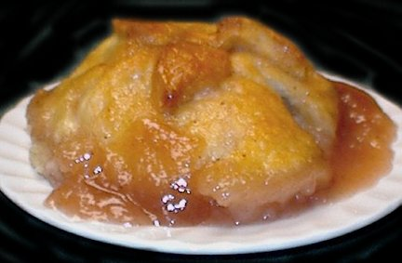

**Free Will Offering**

(11:30 a.m. – 1:00 p.m.)



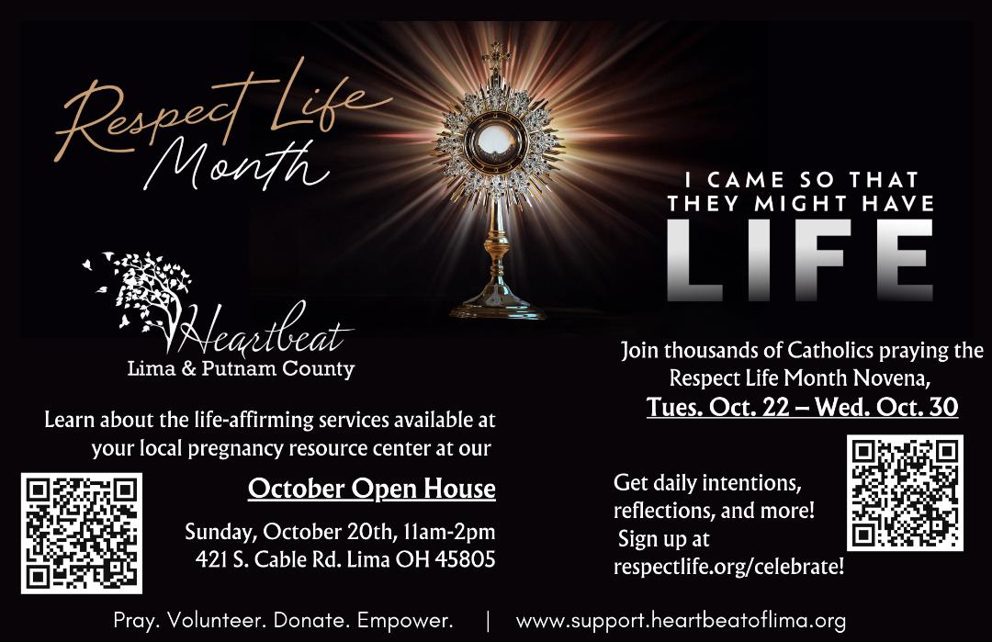

**Landeck**

**SUNDAY, NOVEMBER 3rd**

**Serving 3:00 p.m. -6:30 p.m.**

**SAUSAGE & HOMEMADE SAUERKRAUT**

**- Or -**

**PANCAKES & SAUSAGE**

**Mashed Potatoes Applesauce Pie**

**Dine-In or Drive Thru AVAILABLE**

**Cost: $12.00**