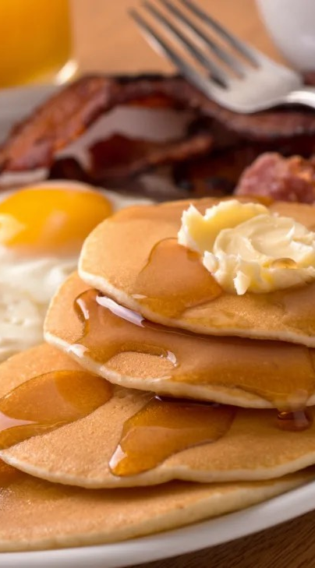

Landeck
St. John the Baptist
Catholic Church
14755 Landeck Road

BREAKFAST
SAUSAGE, PANCAKES,
EGGS, BURRITOS, TOAST,
COFFEE & JUICE

SUNDAY
September 28TH
Landeck Church Basement

Serving 9:00 a.m. to 12:00 noon
Free Will Offering

