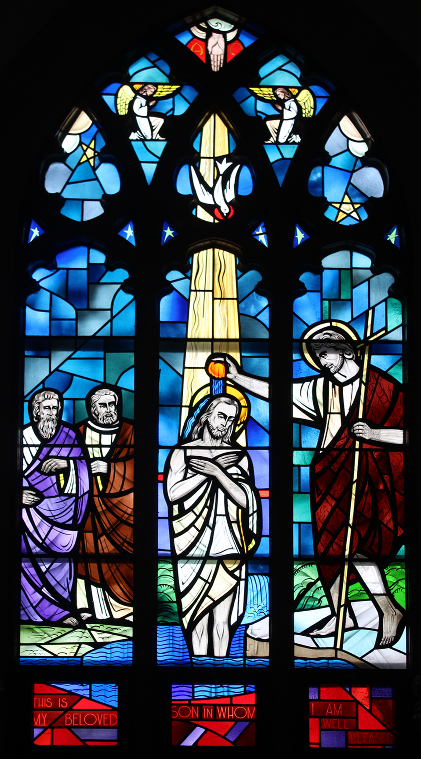

ST. JOHN THE BAPTIST CATHOLIC CHURCH

14755 Landeck Road, Delphos, OH 45833

stjohnthebaptistchurchlandeck.org

**Mass Times**

Sunday 8:30 a.m. and 5:30 p.m.

Monday 7:00 p.m.

**Parish Office Hours**

Monday - Friday

9:00 a.m.-1:00 p.m.

**Reconciliation**

Sunday 8:00 a.m.-8:15 a.m.

**Anointing of the Sick**

419-695-4050

**Baptism**

Please call the parish office three months prior to your child’s baptismal date to schedule pre-baptismal instructions.

**Matrimony**

Please contact Sister Immacolata at least six months in advance to schedule your wedding preparation and celebration.

**Pastor**

Rev. Jeff Walker

jwalker@delphosstjohns.org

**Associate Pastors**

Rev. Tony Vera

frtonyvera@delphosstjohns.org

Rev. Thomas Hunyor

thunyor@delphosstjohns.org

**Parish Manager**

Sr. Immacolata, SCC

570-815-1179

**Parish Secretary**

Mary Lou Weber

churchoffice@stjohnthebaptistchurchlandeck.org

**Parish House**

419-692-0636

**Emergency Phone**

419-513-0415

September 29, 2024| 26th SUNDAY IN ORDINARY TIME

**Please pray for…**Anita Bertsch, Sam Bonifas, Marvin Brenneman, Janice Etzkorn, Leonard Etzkorn, Tony Kahle, Marilyn Heitz, Tom and Darlene Klausing, Fr. Bob Kill, Joan Mason, Clara McVey, Joan Minning, Gerry Mueller, Jodi Parsons, Patti Poling, Kenzie Ray, Ann Rees, Kristy Ringwald, and Dorothy Trentman.

**Thank You**

A great big **THANK YOU** to Jo and Jake Miller for hosting the “cabbage cutting” group last Tuesday evening. God bless all who participated. We had a record number of people show up to help. Also, deep gratitude to Duane Schulte for organizing this upcoming autumn event. Please mark your calendar now for the “Sausage and Sauerkraut” dinner on **November 3rd.**

**Thank You**

The Venedocia Lions would like to thank the Landeck Foresters, Venedocia Lads and Lassies 4-H Club and all the volunteers who helped during the fair. We really appreciate your help and it truly made our booth a success. Thank you so much!

**Gentle Reminder**

If you have not yet made a gift to this year’s Annual Appeal of our Diocese (ACA), we invite you to please pray about it. We would appreciate any donations, since we still need $2,004.00 to meet our goal.  Thank you so much.

**Grandparents’ Sunday**

We would like to offer a special Mass on October 20th for all grandparents—accompanied by as many of their grandchildren as possible!  Mass will be offered in thanksgiving for God’s great gift of grandparents to our families. There will be refreshments and socializing right after Mass in the Church basement.

The Foresters will host coffee and donuts. Please come and spend some enjoyable time together. Thank you!

Please call the parish office if you are able to attend this celebration of Mass and refreshments. Hope to see you there!

**Support our retired diocesan priests**

Our priests have given their lives in service to us and our parish, and we are most grateful! Please offer your gratitude for those who faithfully served the Diocese of Toledo by donating to the 2024 ***Perpetuate The Gift*** Appeal. You gift enables them to cover their daily living costs which continue to rise.

A gift of cash or check can be sent to ***Perpetuate The Gift***, PO Box 954, Toledo, OH 43697, or placed in the parish collection. You can also go online at [www.toledodiocese.org](http://www.toledodiocese.org) under the**Give** tab to make your gift or use the QR code. THANK YOU for your support!

(We will have extra envelopes in the bulletins next Sunday)

**Vestments Still Available**

There are still a few vestments available, if anyone is interested in purchasing one as a memorial gift.  Our new sets for both priests and deacons are just about complete. See Sister Immacolata for more information.

**“Spiritual Bouquet” for Bishop Thomas 10-year Anniversary**

In celebration of Bishop Daniel E. Thomas' 10-year anniversary as Bishop of the Diocese of Toledo, we are building a "spiritual bouquet" to present to him. You are invited to offer prayers, Holy Hours, Masses, Fasting, or Acts of Charity in thanksgiving for Bishop Thomas' ten years of service in the Diocese of Toledo. Visit [toledodiocese.org/10years](https://email-mg.flocknote.com/c/eJwUy0FyhSAMANDTwNIhAQQWWXTjPTTEamvJH6Gd6e3_eIBXKYHHFKwQJAzBzyV7e1DyWHjdtriG7LLMJbErUGPgGLdUwJ6EDoPL6CHDjDDhhrtAiRwL7uzZBLdfyt9Nh0ysP_aiY4yX8R8GF4PL0Euq1lNZukx6fxpcwP3Lenf7mLMSpjmDj8XeVH8br80EV-V6Hdr7-NKj9cfZP8J3AAAA__85czsz) to send in your offerings for the spiritual bouquet. They will be presented to Bishop Thomas on October 22, 2024. *Please note: This will be a surprise for Bishop Thomas! Please do not mention it to him.*

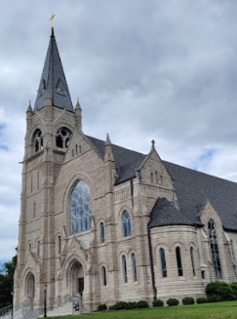**This Week in Parish History**

This past Friday our former pastor Fr. (now Bishop) Dennis Walsh was ordained as the 10th bishop of Davenport, Iowa. The Diocese of Davenport, Iowa was established On May 8, 1881, by Pope Leo XIII. Monsignor John McMullen was appointed as the first bishop. Originally the diocese consisted of all of southern Iowa but in 1911 the Diocese of Des Moines was created in the western half of the diocese. The Cathedral of the Sacred Heart was built in 1891 and replaced St. Margaret’s Cathedral, which had been built in 1856. ~Written by Jack Bockey

**Let There Be Music**

Our adult choir will resume rehearsals on October 7, and sing for Mass on October 13. New members (along with those that have been giving service for years) are very welcome! Remember, St. Augustine said that to sing is to pray twice!

**107th Annual Gymanfa Ganu “A Singing Festival”**

Gomer Congregational Church wishes to extend an invitation to the 107th Annual Gymanfa Ganu “A Singing Festival” directed by Jill Sandy Coston, which will be on Sunday, October 6, beginning at 7:00 p.m. The Welsh Museum will be open from 4:00 p.m. to 6:00 p.m. For more information, please call 419-642-2681.

**Prayers Welcome**

Sister Immacolata will have her next scans and IV Chemotherapy treatment on Tuesday, October 1st at Cleveland Clinic. All prayers are deeply appreciated.

**Mass Intentions**

(**26th Sunday in Ordinary Time ~ September 29th)**

**8:30 a.m. –** Robert Westrick

Angie Vulgamott

Arnold and Beatrice Bockey

**5:30 p.m.** – Blessings on Bishop Dennis Walsh

**(Monday ~ September 30th)**

**7:00 p.m. –** Melvin Pohlman

(**27th Sunday in Ordinary Time ~ October 6th)**

**8:30 a.m. –** James “Hanse” Schwinnen

John Geise

**5:30 p.m.** – Cindy Wright

**(Monday ~ October 7th)**

**7:00 p.m. –** Nancy Shaffer

**(Monday ~ August 12th)**

**7:00 p.m. –** Souls in Purgatory

**Last Weekend’s Gifts**

**September 22, 2024**

**Total: $2,445.20**

Sunday Envelopes: $2,153.20

Maintenance: $40.00

Loose Offering: $210.00

Children’s Loose: $7.00

Landscaping: $35.00

Capital Campaign for this week:



**Thank you for your generosity!**

**Ministry Schedule**

|  |  |  |  |
| --- | --- | --- | --- |
| **26th Sunday in Ordinary Time**  **Sepetmber 29th ~ 8:30 a.m. Mass** | | **27th Sunday in Ordinary Time**  **October 6th ~ 8:30 a.m. Mass** | |
| **Sunday Rosary** | Ginny DiSalle | **Sunday Rosary** | Dorothy Bonifas |
| **Gift Offering** | Bockey Family | **Gift Offering** | Geise Family |
| **Lectors** | 1st Reading –Jane Stirn  2nd Reading – Dolly Martin | **Lectors** | 1st Reading –Eric Kerner  2nd Reading – Joe Rode |
| **Commentator** | Ben Rahrig | **Commentator** | Martha Miller |
| **Communion Distributors** | Jann Bonifas, Nancy Kroeger,  Pat Flanagan  Choir: Casey Flanagan | **Communion Distributors** | Mike Berelsman, Steve Bockey,  Linda Martin  Choir: Jeff Martin |
| **Servers** | Quinn Flanagan  Luke Rode  Lani Warnement | **Servers** | Olivia Bloom  Sophia Bloom  Megan Kerner |
| **Cantor** | Melanie Mueller | **Cantor** | Children’s Choir |
| **Usher** | Bob Trentman | **Usher** | Keith Fischbach |
| **Projector** | Casey Flanagan | **Projector** | Megan Hoersten |
| **Mass Set-Up** | Matt Etzkorn | **Mass Set-Up** | Ken Miller |
| **Money Counters** | Dick and Marilyn Heitz  Rick and Karen Stant | **Money Counters** | Larry and Nancy Kroeger  Jeff and Linda Martin |

~If there is something you would like placed in the parish bulletin, please contact the Parish Office no later than **Wednesday** at **12:00 p.m.** prior to the weekend you want your information published.

**Worship Schedule**

|  |  |
| --- | --- |
| **26th Sunday in Ordinary Time**  **September 29th ~ 8:30 a.m. Mass** | **27th Sunday in Ordinary Time**  **October 6th ~ 8:30 a.m. Mass** |
| 8:00 a.m. - 8:15 a.m. – Confessions | 8:00 a.m. - 8:15 a.m. – Confessions |
| 8:30 a.m. – Mass | 8:30 a.m. – Mass |
| 5:30 p.m. - Mass | 5:30 p.m. - Mass |
|  |  |
| **Monday, September 30th** | **Monday, October 7th** |
| 4:00 p.m. - 6:45 p.m. – Adoration | 4:00 p.m. - 6:45 p.m. – Adoration |
| 6:45 p.m. -Benediction | 6:45 p.m. -Benediction |
| 7:00 p.m. Mass | 7:00 p.m. Mass |

**More Important Information**

**From the Delphos K of C…**

**Photos for Bishop Dennis Walsh Installation**

In anticipation of the Celebration for Bishop Dennis G. Walsh on Saturday November 16, 2024 we are requesting help from your parish. We are putting together a timeline of his last decade of ministry in the Delphos, Ohio area that will be displayed on a television, during the Celebration at the K of C Hall. Please gather your photographs of Father Walsh’s journey with you! Photos of Baptisms, First Communions, Weddings, event celebrations and fun photos of your Priest in action! Photographs may be electronically sent to: tomrode.kofc@gmail.com or placed in an envelope marked with your name, telephone number, and the number of photos enclosed. These photographs may be left at the church office, they will be picked up, scanned and returned in a timely manner. The deadline for all submitted photos is: Sunday October 20, 2024. Thank you for your participation in this exciting endeavor! We look forward to seeing you at the November 16 Celebration!

**PRIESTHOOD SUNDAY**

**(TODAY September 29, 2024)**

PLEASE HONOR ALL OUR PRIESTS ON THIS SPECIAL DAY

(We will have a basket on the table in back of Church if anyone

wants to write them a note of thanks)

